A Seminar Report on

**EVOLUTION OF MICROPROCESSORS**

Presented by

**SOUMIK DAS [20190102027]**

**MERINA BARO [20190102018]**

**TERESHA BASUMATARY [20190102007]**

**RAJ DEBNATH [20190102015]**

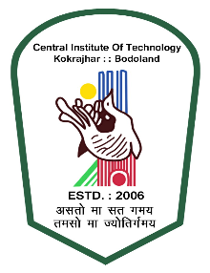

### DEPARTMENT OF COMPUTER SCIENCE & ENGINEERING

CENTRAL INSTITUTE OF TECHNOLOGY, KOKRAJHAR

1. *(Deemed to be University, MoE, Govt. of India)*
2. Kokrajhar – 783370, BTAD, Assam, India

# CONTENTS

**1. Introduction 3**

**2. What is a Microprocessor 4**

**3.** **Evolution of Microprocessor 6**

**4.** **Monopoly of Companies 10**

* Why only Intel and Amd? 10
* Availability of architectures 13
* Forgotten history of Amd 14
* Current market status 15

**5.** **The rise of mobile soc 16**

**6.** **India’s contributions in microprocessors industry 17**

**7. Conclusion 18**

**8. Reference 19**

**Introduction**

The first microprocessors were designed and manufactured in the 1970s. Intel's 4004 of 1971 is widely regarded as the first commercial microprocessor.

Designers predominantly used MOSFET transistors with pMOS logic in the early 1970s, switching to nMOS logic after the mid-1970s. nMOS had the advantage that it could run on a single voltage, typically +5V, which simplified the power supply requirements and allowed it to be easily interfaced with the wide variety of +5V transistor-transistor logic (TTL) devices. nMOS had the disadvantage that it was more susceptible to electronic noise generated by slight impurities in the underlying silicon material, and it was not until the mid-1970s that these, sodium in particular, were successfully removed to the required levels. At that time, around 1975, nMOS quickly took over the market.

This corresponded with the introduction of new semiconductor masking systems, notably the Micralign system from Perkin-Elmer. Micralign projected an image of the mask onto the silicon wafer, never touching it directly, which eliminated the previous problems when the mask would be lifted off the surface and take away some of the photoresist along with it, ruining the chips on that portion of the wafer. By reducing the number of flawed chips, from about 70% to 10%, the cost of complex designs like early microprocessors fell by the same amount. Systems based on contact aligners cost on the order of $300 in single-unit quantities, the MOS 6502, designed specifically to take advantage of these improvements, cost only $25.

This period also saw considerable experimentation with various word lengths. Early on, 4-bit processors were common, like the Intel 4004, simply because making a wider word length could not be accomplished cost-effectively in the room available on the small wafers of the era, especially when the majority would be defective. As yields improved, wafer sizes grew, and feature size continued to be reduced, more complex 8-bit designs emerged like the Intel 8080 and 6502. 16-bit processors emerged early but were expensive; by the decade's end, low-cost 16-bit designs like the Zilog Z8000 were becoming common. Some unusual word lengths were also produced, including 12-bit and 20-bit, often matching a design that had previously been implemented in a multi-chip format in a minicomputer. These had largely disappeared by the end of the decade as minicomputers moved to 32-bit formats.

**What is a Microprocessor**

A microprocessor is the most important unit within a computer system and is responsible for processing the unique set of instructions and processes. A microprocessor is designed to execute logical and computational tasks with typical operations such as addition/subtraction, interprocess and device communication, input/output management, etc. A microprocessor is composed of integrated circuits that hold thousands of transistors; exactly how many depends on its relative computing power. Microprocessors are generally classified according to the number of instructions they can process within a given time, their clock speed measured in megahertz and the number of bits used per instruction. A microprocessor consists of an ALU, control unit and register array. Where **ALU** performs arithmetic and logical operations on the data received from an input device or memory. Control unit controls the instructions and flow of data within the computer. And, **register array** consists of registers identified by letters like B, C, D, E, H, L, and accumulator.

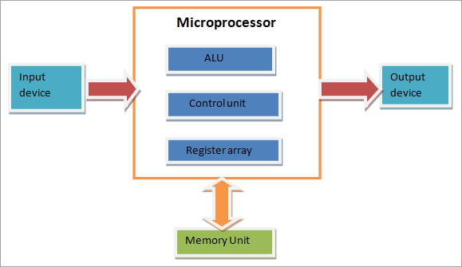

Basic working achitecture of mup (micro-processors)

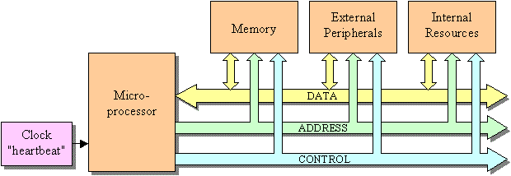Basic working principle of motherboard

**Evolution of Microprocessor**

The first microprocessor introduced in 1971 was a 4-bit microprocessor with 5KB memory and had a set of 45 instructions. In the past 5 decades microprocessor speed has doubled every two years, as predicted by Gordon Moore, Intel co-founder. Current microprocessors can access 64 GB memory. Depending on width of data microprocessors can process, they are of these categories−

* 8-bit
* 16-bit
* 32-bit
* 64-bit

Size of instruction set is another important consideration while categorizing microprocessors. Initially, microprocessors had very small instructions sets because complex hardware was expensive as well as difficult to build. As technology developed to overcome these issues, more and more complex instructions were added to increase functionality of the microprocessor. However, soon it was realized that having large instruction sets was counterproductive as many instructions that were rarely used sat idle on precious memory space. So the old school of thought that supported smaller instruction sets gained popularity.

Let us learn more about the two types of microprocessors based on their instruction set.

**RISC**

RISC stands for Reduced Instruction Set Computers. It has a small set of highly optimized instructions. Complex instruction are also implemented using simpler instructions, reducing the size of instruction set. The designing philosophy for RISC incorporates these salient points −

* Number of instructions should be minimum.
* Instructions should be of same length.
* Simple addressing modes should be used
* Reduce memory references to retrieve operands by adding registers

Some of the techniques used by RISC architecture include −

* Pipelining− A sequence of instructions is fetched even if it means overlapping of instructions in fetching and execution.
* Single cycle execution − Most of RISC instructions take one CPU cycle to execute.

Examples of RISC processors are Intel P6, Pentium4, AMD K6 and K7, etc.

**CISC**

CISC stands for Complex Instruction Set Computers. It supports hundreds of instructions. Computers supporting CISC can accomplish wide variety of tasks, making them ideal for personal computers. These are some characteristics of CISC architecture −

* Larger set of instructions
* Instructions are of variable length
* Complex addressing modes
* Instructions take more than one clock cycle
* Work well with simpler compilers

Examples of CISC processors are Intel 386 & 486, Pentium, Pentium II and III, Motorola 68000, etc.

**EPIC**

EPIC stands for Explicitly Parallel Instruction Computing. It is a computer architecture that is a cross between RISC and CISC, trying to provide the best of both. Its important features include −

* Parallel instructions rather than fixed width
* Mechanism to communication compiler’s execution plan to hardware
* Programs must have sequential semantics

Some EPIC processors are Intel IA-64, Itanium, etc.

Generation of Microprocessor

**1st Generation**

|  |  |  |  |  |
| --- | --- | --- | --- | --- |
| Name | Year of Invention | Clock speed | Number of transistors | Inst. per sec |
| INTEL 4004/4040 | 1971 by Ted Hoff and Stanley Mazor | 740 kHz | 2300 | 60,000 |

This was the period during 1971 to 1973 of microprocessor’s history. In 1971, INTEL created the first microprocessor 4004 that would run at a clock speed of 108 KHz.With only 4 bits as the word size, the 4004 could only represent signed numbers in the range -8 to +7, which is indeed very small. So, it was not really of practical use for arithmetic calculations. However, it found applications in controlling devices.

**2nd Generation**

|  |  |  |  |  |
| --- | --- | --- | --- | --- |
| Name | Year of Invention | Clock speed | Number of transistors | Inst. per sec |
| 8008 | 1972 | 500 kHz | 3500 | 50,000 |
| 8080 | 1974 | 2 MHz | 6000 | 10 times faster than 8008 |
| 8085 | 1976 (16-bit address bus) | 3 MHz | 6500 | 769230 |

Intel 8008 was the next in the evolution, the first 8-bit microprocessor. This was in the year 1972. This was soon followed by Intel 8080, also an 8-bit microprocessor. Intel 8080 was the first commercially popular 8bit microprocessor. With 8 bits as the word size, it could represent signed numbers in the range of −128 to +127. This is also not a good enough range for performing arithmetic calculations. Thus, the 8080 also was used only for control applications. Some other microprocessors like 6800 from Motorola, Z-80 from Zilog were also Popular at this time. They were costly as they were based on NMOS technology fabrication and also for their superfast speed.

**3rd Generation**

|  |  |  |  |  |
| --- | --- | --- | --- | --- |
| Name | Year of Invention | Clock speed | Number of transistors | Inst. per sec |
| 8086 | 1978 (multiply and divide instruction, 16-bit data bus and 20-bit address bus) | 4.77 MHz, 8 MHz, 10 MHz | 29000 | 2.5 Million |
| 8088 | 1979 (cheaper version of 8086 and 8-bit external bus) |  |  | 2.5 Million |
| 80186/80188 | 1982 (80188 cheaper version of 80186, and additional components like interrupt controller, clock generator, local bus controller, counters) | 6 MHz |  |  |
| 80286 | 1982 (data bus 16bit and address bus 24 bit) | 8 MHz | 134000 | 4 Million |

Around 1978, Intel released 8086, the first 16-bit microprocessor. With 16-bit word size, it was possible to represent signed numbers in the range of −32,768 to +32,767, which is quite a decent range for performing arithmetic calculations. As such, this processor became very popular not only for control applications, but also for number crunching operations. Speeds of those processors were four times better than the 2nd generation processors. Not to be outdone, Motorola came out with 68000, their 16-bit processor. Zilog released Z-8000, again a 16-bit processor. These are the most popular 16-bit processors.

**4th Generation**

|  |  |  |  |  |
| --- | --- | --- | --- | --- |
| Name | Year of Invention | Clock speed | Number of transistors | Inst. per sec |
| INTEL 80386 | 1986 (other versions 80386DX, 80386SX, 80386SL , and data bus 32-bit address bus 32 bit) | 16 MHz – 33 MHz | 275000 |  |
| INTEL 80486 | 1986 (other versions 80486DX, 80486SX, 80486DX2, 80486DX4) | 16 MHz – 100 MHz | 1.2 Million transistors | 8 KB of cache memory |
| PENTIUM | 1993 | 66 MHz |  | Cache memory 8 bit for instructions 8 bit for data |

In the early 80s, Intel released the 32-bit processor, the Intel 80386, by using HCMOS fabrication. With 32-bit word size, it was possible to represent signed numbers in the range ±2×109, which is quite a large range for performing arithmetic calculations. If floating point notation is used, it can represent much larger numbers. As such, this processor became very popular as the CPU in computers for number crunching operations. At this time, Motorola came out with 68020, their 32-bit processor. Intel released 80486, which was basically an 80386 processor and 80387 numeric co-processor on a single chip. Motorola released 68030. In the early 90s, Intel released 80586 by the name Pentium processor. It is extremely fast in performing arithmetic calculations and executing instructions. The Pentium 4 released in 2000 has 42 Million transistors worked with a clock speed of 1.5 GHz and is rated for 1500 MIPS (Million instructions per second).

**5th Generation**

|  |  |  |  |  |
| --- | --- | --- | --- | --- |
| Name | Year of Invention | Clock speed | Number of transistors | Inst. per sec |
| INTEL core 2 | 2006 (other versions core2 duo, core2 quad, core2 extreme) | 1.2 GHz to 3 GHz | 291 Million transistors | 64 KB of L1 cache per core 4 MB of L2 cache |
| i3, i5, i7 | 2007, 2009, 2010 | 2.2GHz – 3.3GHz, 2.4GHz – 3.6GHz, 2.93GHz – 3.33GHz |  |  |

From 1995 to until now this generation has been bringing out high-performance and high-speed processors that make use of 64-bit processors. The present-day computers based on microprocessors are already faster than the mini computers and sometimes the main frame computers of yesteryear, and they are available at a small fraction of the cost of such main frame computers.

**Monopoly of Companies**

**Intel Corporation** and **AMD** are the most dominant and pervasive technology companies in the world. The business essentially operates as a monopoly in its core computer and data center markets and has numerous competitive advantages that are virtually impossible to replicate by most companies. Both companies were founded over 50 years ago in what has become the Silicon Valley part of California. Yet, in half a century, no other major player has been able to dominate the semiconductor market segment the way these two companies have.

**Why only Intel and Amd?**

We'll take a look at the history of competition between Intel and AMD and try to explain why AMD has been, and remains, Intel's only real competitor. Intel was co-founded in mid-1968 by Gordon Moore, known for formulating Moore's Law, and by Robert Noyce, who helped invent the silicon integrated circuit. Both men were former employees of Fairchild Semiconductor, an early and influential pioneer in integrated circuit technology.AMD was founded a few months later in 1969, also by former employees of Fairchild Semiconductor.The two companies have, therefore, a shared lineage and similar origins. Since then, they have been fierce competitors, both trying to one-up each other with the latest technology and most powerful processors to run the world's computers. Soon after developing its x86 chipset and its initial public offering (IPO) in 1971, Intel became the dominant player in the microprocessor industry.5 As of August 2021, Intel's market capitalization is $213 billion,6 compared to AMD's market cap of $127 billion.For much of its history, AMD has been the persistent underdog to Intel in the semiconductor space. Intel has tended to dominate all sectors of the CPU market, including high-end performance processors. AMD focused on lower-cost, budget-friendly middle- and low-range chipsets. For many years, Intel chips had the reputation of being more stable and easy to use for the average computer user. Meanwhile, sophisticated users who knew their way around a circuit board were able to tinker with AMD's chips, which could be overclocked (a method for getting a CPU to run at a faster speed). For many years it seemed like AMD was destined to play second fiddle to Intel in microprocessor market share. Up until about 2016, AMD controlled around one-quarter of the CPU market, while Intel dominated more than 70%.

**Availability of architectures**

Even after 50 years of the initial release of x86 chipsets, till date one can only get their hands on a very few selected complete/raw architectures of intel’s microprocessors, they have been avoiding US’s federal trust law of avoiding monopoly in markets by playing a double card game with this one and only competitor AMD, for layman it may seem like Amd and Intel’s relationship is just limited to competing with each other or more like enemies but under the table they are the long lived allies that are never really going to stop helping each other keep their monopoly in the market. They make it seem legal to us govt. by competing to each other and giving away licences of old chips like 8085, 80386 and etc. that there’s no monopoly in the market but indirectly becomes the only companies and the dominant body of the semi-conductors and microprocessors industry. These are some examples of the few completely available 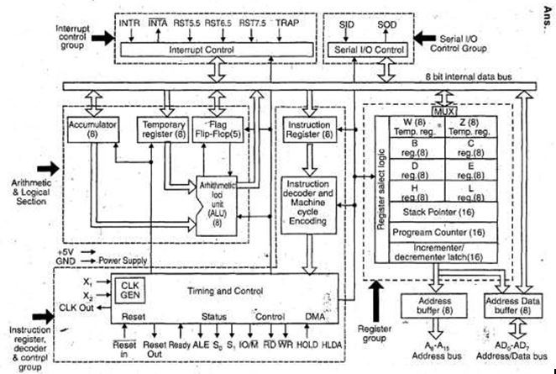microprocessor architectures:

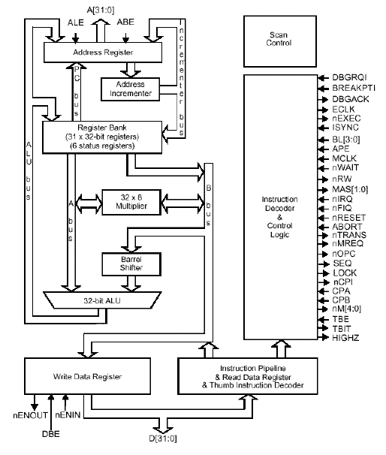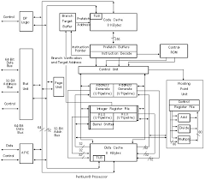

**Forgotten history of Amd**

AMD was founded in 1969 by Walter Jeremiah (“Jerry”) Sanders, a former executive at  Fairchild Semiconductor Corporation, and seven others. The company released its first product in 1970 and went public two years later. In the mid-1970s the company began producing computer chips. Starting out as a second-source manufacturer of computer chips, the company placed a great emphasis on quality and grew steadily. In 1982 the company began supplying second-source chips for Intel Corporation, which made the microprocessor used in IBM personal computers (PCs). The agreement with Intel ended in 1986. In 1991 AMD released the Am386 microprocessor family, a reverse-engineered chip that was compatible with Intel’s next-generation 32-bit 386 microprocessor. There ensued a long legal battle that was finally decided in a 1994 U.S. Supreme Court ruling in AMD’s favour. That same year, Compaq Computer Corporation contracted with AMD to produce Intel-compatible chips for their computers. In 1996 AMD acquired a microprocessor company known as NexGen and began branching out from the Intel-compatible chip market. In 2000 AMD introduced the Athlon processor, which was designed to run the Microsoft Corporation’s Windows operating system. With the release of the Athlon processor, AMD became the first company to produce a 1-GHz (gigahertz) microprocessor, which marked AMD as a serious competitor in the chip market. In 2003 the company released the Opteron chip, another product that showcased the company’s ability to produce high-end chips. In 2006 AMD absorbed ATI Technologies, a manufacturer of video graphics cards for use in PCs. In 2008 AMD announced plans to split the company in two—with one part designing microprocessors and the other manufacturing them. This announcement followed news that the Advanced Technology Investment Company and the Mubadala Development Company, both based in Abu Dhabi, would acquire a controlling interest in AMD, pending approval by shareholders and the U.S. and German governments. In 2009, following a series of complaints lodged by AMD, the European Commission fined rival Intel a record €1.06 billion (£948 million; $1.45 billion) for engaging in anticompetitive practices that violated the European Union’s antitrust laws. These practices allegedly involved financially compensating and providing rebates to manufacturers and retailers who favoured its computer chips over those of AMD, as well as paying manufacturers to cancel or postpone the launching of products utilizing AMD’s chips.

**Current market status**

We can say finally after so many years, any company succeeded to make a processor that actually gives a toe to toe competition to Intel and Amd’s consumer grade CPUs, We are talking about none other than Apple’s M1 chip, when apple launched their m1 chipset on 2020, no one expected that a Arm based chip will give some tough time to intel and amd’s x64 chipsets, **Apple M1** is a series of [ARM](https://en.wikipedia.org/wiki/ARM_architecture)-based [system-on-a-chips](https://en.wikipedia.org/wiki/System-on-a-chip) (SoCs) [designed by Apple Inc.](https://en.wikipedia.org/wiki/Apple_silicon)  for its [Macintosh](https://en.wikipedia.org/wiki/Macintosh) [desktops](https://en.wikipedia.org/wiki/Desktop_computer) and [notebooks](https://en.wikipedia.org/wiki/Laptop). The M1 chip initiated Apple's third [change](https://en.wikipedia.org/wiki/Mac_transition_to_Apple_silicon) to the [instruction set architecture](https://en.wikipedia.org/wiki/Instruction_set_architecture) used by Macintosh computers, switching from [Intel](https://en.wikipedia.org/wiki/Intel) to [Apple silicon](https://en.wikipedia.org/wiki/Apple_silicon) 14 years after they were [switched from PowerPC to Intel](https://en.wikipedia.org/wiki/Mac_transition_to_Intel_processors), and 26 years after the transition from the original [Motorola 68000 series](https://en.wikipedia.org/wiki/Motorola_68000_series) to [PowerPC](https://en.wikipedia.org/wiki/PowerPC). At the time of introduction in 2020, Apple said that the M1 had the world's fastest CPU core "in low power silicon" and the world's best CPU [performance per watt](https://en.wikipedia.org/wiki/Performance_per_watt). Its successor, [Apple M2](https://en.wikipedia.org/wiki/Apple_M2), was announced on June 6, 2022 at [WWDC](https://en.wikipedia.org/wiki/WWDC). The **M1** was introduced in November 2020. The M1 was followed by the professional-focused **M1 Pro** and **M1 Max** chips in 2021. The M1 Max is a higher-powered version of the M1 Pro, with more [GPU](https://en.wikipedia.org/wiki/GPU) cores and [memory bandwidth](https://en.wikipedia.org/wiki/Memory_bandwidth) and a larger [die size](https://en.wikipedia.org/wiki/Die_(integrated_circuit)). Apple introduced the **M1 Ultra** in 2022, combining two M1 Max chips in one package. These chips differ largely in size and the number of functional units: for example, while the original M1 has about 16 billion [transistors](https://en.wikipedia.org/wiki/Transistor), the M1 Ultra has 114 billion. But as expected it seems like apple will do the same and try to join the monopoly market just by limiting their chips to only support macOS or initially Apple products, So there’s not really any chance that non-apple consumer grade pc will get to have a new option other then Intel/Amd. The M1 has four high-performance "Firestorm" and four energy-efficient "Icestorm" [cores](https://en.wikipedia.org/wiki/Multi-core_processor), first seen on the [A14 Bionic](https://en.wikipedia.org/wiki/Apple_A14). It has a [hybrid](https://en.wikipedia.org/wiki/Heterogeneous_computing#Heterogeneous_CPU_topology) configuration similar to [ARM DynamIQ](https://en.wikipedia.org/wiki/ARM_DynamIQ) and Intel's [Lakefield](https://en.wikipedia.org/wiki/Tremont_(microarchitecture)#Mobile_processors_(Lakefield)) and [Alder Lake](https://en.wikipedia.org/wiki/Alder_Lake_(microprocessor)) processors. This combination allows power-use optimizations not possible with previous [Apple–Intel architecture](https://en.wikipedia.org/wiki/Apple%E2%80%93Intel_architecture) devices. Apple claims the energy-efficient cores use one-tenth the power of the high-performance ones. The high-performance cores have an unusually large 192 KB of L1 [instruction cache](https://en.wikipedia.org/wiki/CPU_Cache) and 128 KB of L1 data cache and share a 12 MB L2 cache; the energy-efficient cores have a 128 KB L1 instruction cache, 64 KB L1 data cache, and a shared 4 MB L2 cache. The SoC also has a 8MB System Level Cache shared by the GPU. The M1 Pro and M1 Max use the same [ARM big. LITTLE](https://en.wikipedia.org/wiki/ARM_big.LITTLE) design as the M1, with eight high-performance "Firestorm" (six in the [lower-binned](https://en.wikipedia.org/wiki/Product_binning#Semiconductor_manufacturing) variants of the M1 Pro) and two energy-efficient "Icestorm" [cores](https://en.wikipedia.org/wiki/Multi-core_processor), providing a total of ten cores (eight in the lower-binned variants of the M1 Pro). The high-performance cores are clocked at 3228 MHz, and the high-efficiency cores are clocked at 2064 MHz The eight high-performance cores are split into two clusters. Each high-performance cluster shares 12 MB of L2 cache. The two high-efficiency cores share 4 MB of L2 cache. The M1 Pro and M1 Max have 24 MB and 48 MB respectively of system level cache (SLC). The M1 integrates an Apple designed eight-core (seven in some base models) graphics processing unit (GPU). Each GPU core is split into 16 Execution Units, which each contain eight [Arithmetic Logic Units](https://en.wikipedia.org/wiki/Arithmetic_Logic_Unit) (ALUs). In total, the M1 GPU contains up to 128 [Execution units](https://en.wikipedia.org/wiki/Execution_unit) or 1024 ALUs, which Apple says can execute up to 24,576 threads simultaneously and which have a maximum floating point (FP32) performance of 2.6 [TFLOPs](https://en.wikipedia.org/wiki/TFLOPS). The M1 Pro integrates a 16-core (14 in some base models) graphics processing unit (GPU), while the M1 Max integrates a 32-core (24 in some base models) GPU. In total, the M1 Max GPU contains up to 512 [execution units](https://en.wikipedia.org/wiki/Execution_unit) or 4096 ALUs, which have a maximum floating point (FP32) performance of 10.4 [TFLOPs](https://en.wikipedia.org/wiki/TFLOPS). The M1 Ultra features a 48 or 64 core GPU. The M1 contains dedicated [neural network hardware](https://en.wikipedia.org/wiki/AI_accelerator) in a 16-core Neural Engine, capable of executing 11 trillion operations per second.

**The rise of mobile SOCs**

In 2022 it is wrong to say that Intel and Amd still dominated all the microprocessors market because the mobile and notebook’s soc scene has been different lately:

|  |  |  |  |  |  |  |
| --- | --- | --- | --- | --- | --- | --- |
| **Global Smartphone Chipset Market Share (Q4 2020 – Q1 2022)** | | | | | | |
| **Brands** | **Q4 2020** | **Q1 2021** | **Q2 2021** | **Q3 2021** | **Q4 2021** | **Q1 2022** |
| **Mediatek** | **37%** | **39%** | **42%** | **40%** | **33%** | **38%** |
| **Qualcomm** | **23%** | **28%** | **26%** | **27%** | **30%** | **30%** |
| **Apple** | **22%** | **15%** | **14%** | **15%** | **21%** | **15%** |
| **UNISOC** | **4%** | **7%** | **9%** | **10%** | **11%** | **11%** |
| **Samsung** | **7%** | **6%** | **5%** | **5%** | **4%** | **5%** |
| **HiSilicon (Huawei)** | **7%** | **5%** | **3%** | **2%** | **1%** | **1%** |

There’s plenty of big names in market like Samsung’s Exynos, Huawaei’s HiSilicon, Mediatek and etc. but the majority of the time the market is ruled by Qualcomm’s Snapdragon mobile processors series, almost all the chipsets on the market are based on Arm architecture and shares similar working architecture. Whereas the Desktop cpu competition focus on more computing power, the mobile market focuses on the lithography/fabrication or the power consumption of the soc, for instance in 2022 only Samsung and Mediatek came up with their 4nm CPU line-ups, whereas in desktop market the lowest one can get their hands on is 12nm (AMD) for now.

**India’s contributions in microprocessors industry**

In past there’s been many attempts to manufacture our very own made in india microprocessor but one name made it to the headlines i.e. **SHAKTI** – it is an open-source initiative by the Reconfigurable Intelligent Systems Engineering (RISE) group at [Indian Institute of Technology, Madras](https://en.wikipedia.org/wiki/Indian_Institute_of_Technology_Madras) to develop the first indigenous Indian industrial-grade processor. The aim of SHAKTI initiative includes building an opensource production-grade processor, complete System on Chips (SoCs), development boards and SHAKTI based software platform. The primary focus of the team is architecture research to develop SoCs, which is competitive with commercial offerings in the market concerning area, power and performance. All the source codes for SHAKTI are open-sourced under the [Modified BSD License](https://en.wikipedia.org/wiki/BSD_licenses#3-clause_license_(%22BSD_License_2.0%22,_%22Revised_BSD_License%22,_%22New_BSD_License%22,_or_%22Modified_BSD_License%22)). The project was funded by [Ministry of Electronics and Information Technology](https://en.wikipedia.org/wiki/Ministry_of_Electronics_and_Information_Technology) (MeITY), Government of India. SHAKTI comes with 3 series of processors Base-Class, Multicore and Experimental. It is expected that the first set of commercial silicon of Shakti and Vega processors available by **December 2023 or early 2024**.

Here's the example architecture of the C-Class Chipset of SHAKTI:

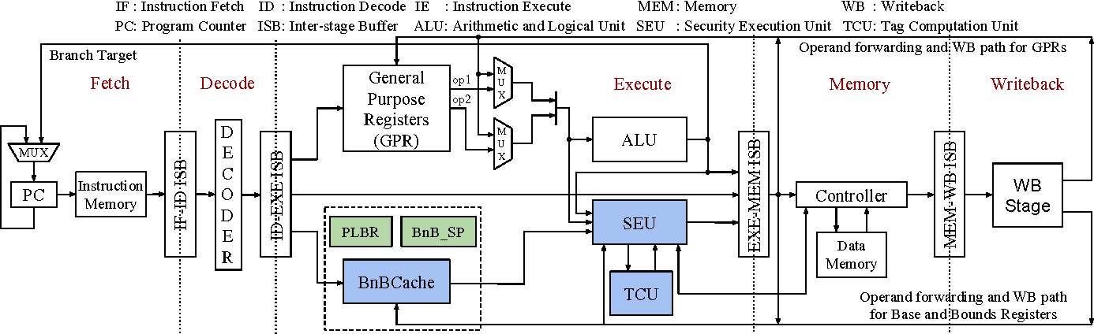

Bus configuration or motherboard working principle of SHAKTI:

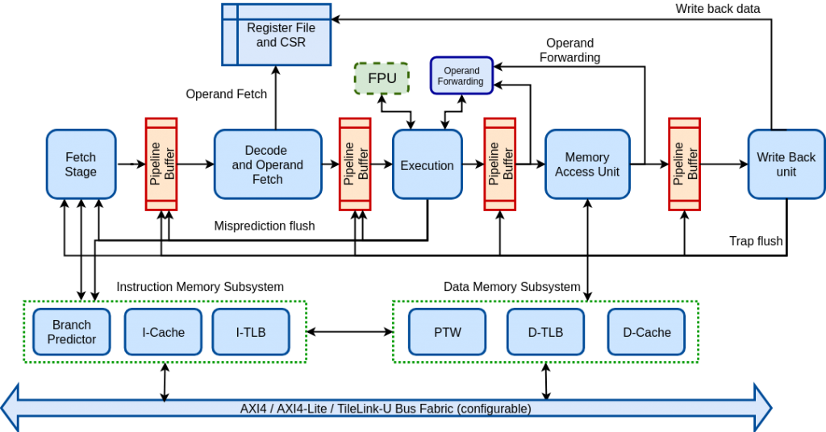

**Conclusion**

We have come a long way from the first computer by IBM to the present power house that fits perfectly in our pocket. This was a small seminar and hopefully we got able to keep you interested on the topic till now, So this is all for now, we did whatever was possible for us in just two days because we got informed about this seminar only a day before so we will do whatever changes is asked by any of you teachers to make it reach your expectations and our academic goals.

**References**

* Main Guide: <https://www.bharatacharyaeducation.com/index.php/channel/index>
* Reference Article: <https://www.javatpoint.com/microprocessor-introduction>
* Reference Article: <https://www.techopedia.com/definition/2874/microprocessor>
* Article on evolution of mup: <https://www.geeksforgeeks.org/evolution-of-microprocessors/>
* Article on History of mup: <https://www.tutorialspoint.com/history-of-microprocessor>
* Wiki page of mup: <https://en.wikipedia.org/wiki/Microprocessor_chronology>
* About intel and amd: <https://www.youtube.com/watch?v=KGMABnrgwRU>
* Article about monopoly of intel: <https://investorplace.com/2016/04/intel-intc-a-technology-monopoly-paying-safe-growing-dividends/>
* about monopoly of intel and amd: <https://www.youtube.com/watch?v=1EEakkh4ZG4>
* Article about monopoly in soc market: <https://www.investopedia.com/insights/why-amd-intels-only-competitor-intc-amd/>
* Video about market status: <https://www.youtube.com/watch?v=8i67R5bnb14>
* History of amd: <https://www.youtube.com/watch?v=K8Lz3ANjlDs>
* Mup market analysis: <https://www.grandviewresearch.com/industry-analysis/microprocessor-market>
* Outcomes of this monopoly: <https://www.youtube.com/watch?v=0SyLqFuf_SU>
* Amd and intel’s fake competition: <https://www.extremetech.com/computing/335650-amd-achieves-all-time-record-x86-market-share-in-q1-2022>
* All about arm cpu: <https://www.youtube.com/watch?v=X4BxUiqWq8E>
* Other soc manufacturers: <https://www.techspot.com/article/2271-the-other-cpu-makers/>
* Article on mobile soc market: <https://www.counterpointresearch.com/global-smartphone-ap-market-share/>
* Wiki page of m1 chip: <https://en.wikipedia.org/wiki/Apple_M1>
* Future of mobile soc market: <https://www.youtube.com/watch?v=lFPnY39Ob_c>
* A make in india SOC: <https://shakti.org.in>
* Wiki page of SHAKTI mup: <https://en.wikipedia.org/wiki/SHAKTI_(microprocessor)>
* Shakti cpu’s performance: <https://www.youtube.com/watch?v=EylVBCGWWD0>
* Nvidia’s plan to enter cpu market: <https://www.youtube.com/watch?v=v0FByWRgjXI>